
pho-com-net Private Limited
11D/1 B.T. Road. Kolkata – 700056
An ISO 9001 : 2015 Company

COMPANY PROFILE
pho-com-net Private Limited
Regd / Work Office 529/A, H. B. Town, Barasat Road,
Purbayan,Sodepur, Kolkata–700 110.
Dial : (91) (033) 25955838, Fax : (91) (033) 25441490
In the Pocket (+91) 98310 11279, (+91) 97484 15507, (+91) 98311 22269
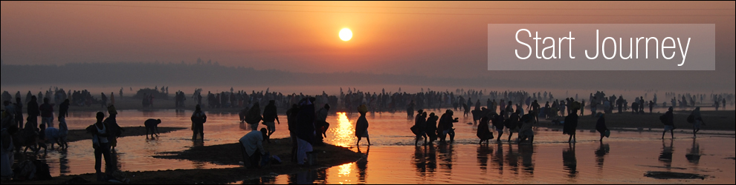
e-mail info@pho-com-net.com, Web www.pho-com-net.com
Pho-com-net Private Limited, An ISO 9001:2015 Company has been incorporated on 2003. Actually the group has started their journey quite earlier on 1999. Pho-Com-Net Private Limited is an IT and ITES , who mainly capitalized its expertise over Software Development, Citizen Centric Application ( E-Governance),Biometric Smart Card Application , Addhar (UIDAI), Financial Inclusion,EPIC & Generation of Photo Roll & Printing, Electronics Database Management System- Digitization & Scanning,Variable Data Printing.

pho-com-net Private Limited
11D/1 B.T. Road. Kolkata – 700056
An ISO 9001 : 2015 Company
Some Services & Solutions:
- Software Development
Our Competent Software Developer Team has developed various software like STQC certified RSBY Enrolment Software, RSBY Renewal Software, RSBY Hospital Transaction Software, District Kiosk Software, RSBY Web Portal for West Bengal Health and Family Welfare, Banking Software etc.
Besides we have our Data Management Tools, Scanning Tools and Web Application Tools.
We developed software to collect the data that will function web based and mobile / tab based application with GIS integration.
- Citizen Centric Application (E-Governance) Through Biometric Application.
Pho-Com-Net Pvt. Ltd. helps Governments become more agile in delivering citizen-centric services and superior public value through biometric application. We provide support to state, local, and provincial governments and enable them to use information technology (IT) to meet new and evolving challenges. The Biometric means life and measurement Respectively.
- Swasthya Sathi (Enrollment with District Kiosk and Hospital Support)
The Department of Health & Family Welfare, Govt. of West Bengal, is going to launch a Group Health Insurance scheme named “Swasthya Sathi”, which is going to be implemented in the state for larger section of the Society including the present beneficiaries covered under RSBY. The scheme will have basic health cover for secondary and tertiary care up to Rs. 1.5 Lakh per annum per family. All pre-existing diseases will be covered. The entire premium will be borne by the State Government with no contribution from the beneficiaries. There will be no cap on the family size. Critical illness like Cancer, Neuro surgeries, cardiothoracic surgeries, liver diseases, blood disorders etc. will be covered up to Rs 5 Lakh per annum per family and the cost thereof will be borne by the State Government.
- Atal Amrit Abhiyan
The main objective of this scheme is to provide coverage against certain 5 diseases including Cancer, Kidney disease, Heart related aliment, Brain related aliment and Burn Injuries. The people belong to the poor families won’t have to pay much higher for the expensive treatment. The Health scheme in assam has been started to the help the families having the lower Income. This AAA program is started to provide a perfect health care to the needy people. The scheme focuses on providing the health Insurance coverage to the people.

- RashtriyaSwasthyaBimaYojana
RSBY has been launched by Ministry of Labour and Employment, Government of India to provide health insurance coverage for Below Poverty Line (BPL) families. The objective of RSBY is to provide protection to BPL households from financial liabilities arising out of health shocks that involve hospitalization. Beneficiaries under RSBY are entitled to hospitalization coverage up to Rs. 30,000/- and for that they need to pay only Rs. 30/- as registration fee.
We provide End to End Solution in RSBY Project with our own Government of India Certified Software from data preparation to district kiosk support including biometric enrollment smart card printing and personalization,
We have already enrolled more than One Crore Twenty TwoLakh BPL families and we have provide hospital Transaction Support to almost 3000 RSBY empanelled Hospital of 10 numbers of State in India 65 numbers of District.

pho-com-net Private Limited
11D/1 B.T. Road. Kolkata – 700056
An ISO 9001 : 2015 Company
- Adhar (UIDAI)
The Aadhaar Card can be defined as a document that carries a 12-digit identification number that is provided to you by the Unique Identification Authority of India (UIDAI) as a representative of the Indian Government. The number acts as an evidence of address and identity of people across all parts of India. One can get the Aadhaar letter, which contains the card itself, through India Post or download it from the UIDAI website. Both will be regarded as equally authentic.
- Employee State Insurance Corporation (ESIC)
We make Data Entry of the ESIC Documents (Declaration Forms of the Insured Persons) and Biometric enrolment of the same at different ESIC Branch Offices.
- Financial Inclusion
Financial inclusion denotes delivery of financial services at an affordable cost to the vast sections of the disadvantaged and low-income groups. The objective of financial inclusion is to extend the scope of activities of the organized financial system to include within its ambit people with low incomes. We have done mass biometric enrolment and personalization for issuance of Smart Card. We have also extended Tech Support to Business Correspondents.
- EPIC, Generation of Photo Electoral Roll, Printing and Live Election coverage.
During the last sixteen years we have successfully implemented various Election projects regarding preparation of Electoral Photo Identity Card, Data Entry, Generation of Photo Electoral Rolls,Printing and Live Election Coverage under different State Government such as West Bengal, Bihar, Orissa, Jharkhand, Assam, Tripura, U.P, M.P, A.P, Rajasthan etc.
- Electronic Document Management Systems
We have implemented the EDMS Projects. We are committed to provide a range of information management solutions and large scale document scanning / digitization services that help our client manage documents / images more efficiently.
- Variable Data Printing – (Using Thermal, Inkjet and Laser Technology)
Variable Data Printing Services is a form of on-demand printing in which elements such as text, graphics and images may be changed from one printed piece to the next, without stopping or slowing down the printing process and using information from a database or external file.

pho-com-net Private Limited
11D/1 B.T. Road. Kolkata – 700056
An ISO 9001 : 2015 Company
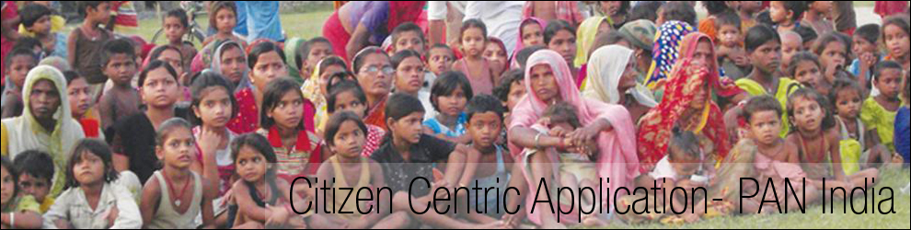
SOME OF OUR CLIENTS

DEPARTMENT OF HEALTH AND FAMILY WELFARE WEST BENGAL, ICICI LOMBARD GENERAL INSURANCE COMPANY, CMC LIMITED., WEBEL TECHNOLOGY PVT. LTD., WEBEL ELECTRO COMMUNICATION SYSTEM LIMITED, SARASWATI PRESS LIMITED., CHIEF ELECTORAL OFFICER TRIPURA., CHIEF ELECTORAL OFFICER ANDHRA PRADESH., CHIEF ELECTORAL OFFICER MADHYAPRADESH, DEDICATED HEALTHCARE SERVICE (TPA) PVT. LTD, HERITAGE HEALTH TPA PVT. LTD., MD INDIA HEALTHCARE (TPA) SERVICE PVT. LTD., E-MEDITEK (TPA) SERVICES LIMITED., SAFEWAY TPA SERVICES (P) LTD., PANCHYET DIRECTOR TRIPURA, DISTRICT MAGISTRATE WEST CHAMPARAN, DISTRICT MAGISTRATE PATNA, DISTRICT MAGISTRATE ROHTAS, DISTRICT MAGISTRATE NALANDA, DISTRICT MAGISTRATE GAYA, DISTRICT MAGISTRATE MUNGER, DISTRICT MAGISTRATE SAMASTIPUR, DISTRICT MAGISTRATE PURBA MIDNAPORE, DISTRICT MAGISTRATE PASCHIM MIDNAPORE.

We are developing the Web Portal for West Bengal Health and Family Welfare Department. This Web Content Management System Portal covers a network of 7000 Hospitals in the entire State of West Bengal (20 numbers of Districts). The family beneficiaries are 60, 63,390 (Sixty Lakh Sixty Three Thousand Three Hundred Ninety).
We have already done Smart Card based Government Sponsored General Insurance Scheme of more than 1 Crore Eighty Lakh family beneficiaries in 65 numbers of districts of 11 no of States in India.
Highest Enrolment in India in any Dist: Burdwan (Policy Yr 2014-15) under NIC 6,93,229

